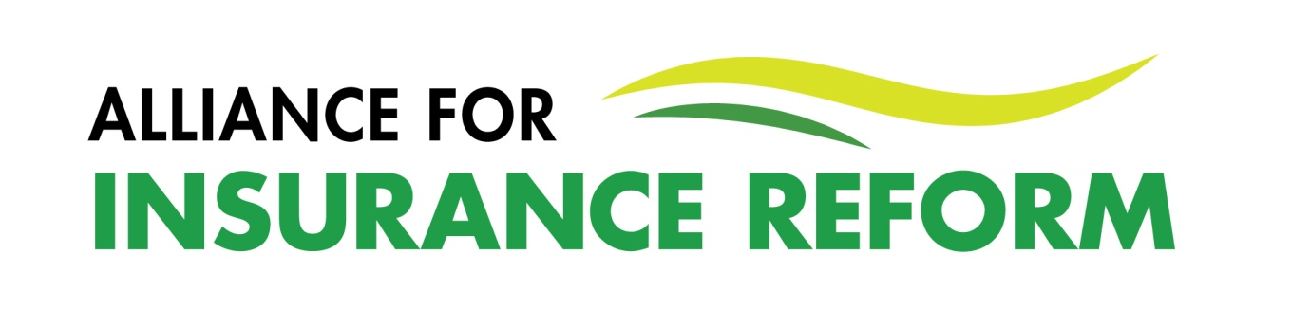1-PAGE MEMBER UPDATE – 13th June 2022
Despite all the ongoing progress on insurance reform, it remains to be seen whether we will get affordable liability insurance now and in the long term. Our ongoing 1-Minute Survey continues to confirm what it has from the beginning in May 2021. Motor insurance is dropping while Liability cover continues to increase in cost by an average of 16%.
There are plenty of significant reforms happening at the moment, but they all come with health warnings.
Damages for minor injuries as assessed by PIAB have been significantly reduced by the Judicial Guidelines. But the Guidelines are subject to a raft of constitutional challenges. The first challenge was recently thrown out by the High Court but may go to appeal. Others await court judgement or are waiting to be heard. Additionally, we have no clear view of how individual judges will implement the Guidelines, although the first few cases to reach the Circuit Court have reportedly seen damages well in excess of the PIAB assessment being awarded. We will have to keep a very close eye on developments in this area.
Positive legislation to rebalance the duty of care has been proposed by Minister McEntee. We have welcomed the legislation but asked that the responsibility of parents and guardians be written into it and that an indictive list of sectors in which a voluntary assumption of risk might be applied be included. Ultimately, speed is of the essence in getting this legislation enacted and we expect this to happen before the end of 2022.
The reform of PIAB is being progressed through Minister of State Robert Troy’s Personal Injuries Resolution Board Bill. This will broaden the type of claims PIAB can handle and will allow for mediation, to avoid cases progressing to litigation. The Alliance presented to the Oireachtas Enterprise Committee’s pre-legislative scrutiny of this Bill in May. What is key at this stage is to get the legislation enacted before Christmas.
In addition, the Garda Insurance Fraud Coordination Office is up and running, the Perjury Act has been commenced and we expect action soon on legal fees, the claims database and defamation legislation. But none of this will benefit us in the long term unless more competition is brought into the Irish insurance market, premiums are reduced and affordable cover becomes more widely available. We await news from the Minister of State responsible, Sean Fleming, on ongoing work with the IDA to attract additional insurers in order to make the liability market competitive now and in the long term.

Peter Boland, 13th June 2022.

